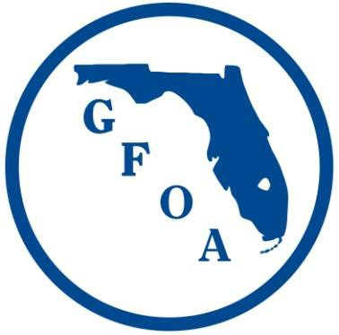
Florida Government Finance Officers Association Social Media Policy
February 3, 2017

Social media includes all Internet, Intranet, and other web-based and mobile technologies used to communicate to the public or our membership. Generally social media tools fall into three categories; channels for disseminating time-sensitive information quickly; marketing/promotional channels that increase the FGFOA’s ability to broadcast its messages to the widest possible audience; and a means to engage in transparent conversations between the FGFOA and its membership. The FGFOA’s use of Internet, Intranet, and other web-based and mobile technologies, including Facebook, Twitter, and YouTube, are considered social media and are subject to this policy.

- The Social Media Committee will designate individuals to comment and update the content on FGFOA’s social media sites. Additionally, individuals designated by the FGFOA Executive Director in consultation with the FGFOA President are also permitted to comment or update content on the FGFOA’s social media sites. These individuals could include Florida League of City staff, committee chairs, board members and chapter presidents.
- Chapter Presidents may use social media to promote Chapter and FGFOA business.
  - Chapter Presidents must adhere to this policy.
  - Chapter Presidents may designate individuals to comment or update content on the Chapter’s social media sites.
  - Chapter Presidents shall update the FGFOA periodically with their Chapter’s social media efforts.
- All FGFOA social media content will be subject to review and approval by the Executive Director, staff, or designated members including a social media committee.

- The FGFOA’s main web site (www.fgfoa.org) is the organization’s primary internet/web presence.

- Other social media sites, such as Facebook and Twitter, will be used as complimentary means of communication to the FGOFA’s official website.
- Comments, articles, or any other content containing any of the following shall not be allowed on any of the FGFOA’s social media sites:
  - Comments in support of or in opposition to political campaigns or ballot measures that are not consistent with adopted Board positions;

  - Content related to advertising services, soliciting business, or distributing other self-promoting material for any individual or “for-profit” organization;

  - Content related to advertising services, soliciting business, or distributing other self- promoting material for any “not-for-profit” or civic organization unless approved by the FGFOA Executive Director in consultation with the FGFOA President;
  - Profane or obscene language;

  - Content that promotes, fosters, or perpetuates discrimination on the basis of race, creed, color, age, religion, gender, genetic identity, marital status, national origin, physical or mental disability, or sexual orientation;

  - Sexual content or links to sexual content;

  - Gambling content or links to gambling content;

  - Conduct or encouragement of illegal activity;

  - Information that may tend to compromise the safety or security of the public or public systems;

  - Content that violates a legal ownership interest of any other party;

  - Content that promotes bullying or harassment;

  - Content that encourages alcohol consumption or the use of legal/illegal drugs;

  - Content that contains confidential or proprietary information about the FGFOA, its members or vendors; and

  - Content that violates another person’s right to privacy.

The FGFOA reserves the right to restrict or remove any content that is deemed in violation of this social media policy.

